**Screenshots:**

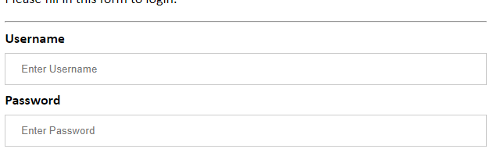

**Fig 5.1: Example of input and label tag**

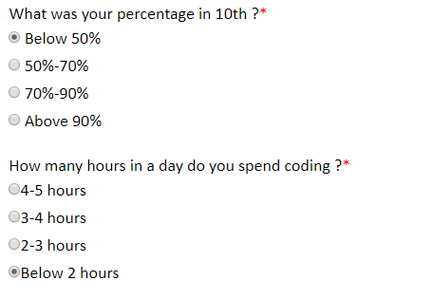

**Fig 5.2: Example input type:radio**



**Fig 5.3: Example of button tag**

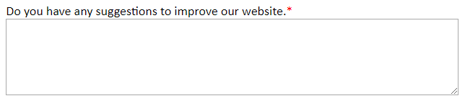

**Fig 5.4: Example of textarea**

**Experiment – 05**

**AIM**: Create a layout for multiple forms using external style sheet for styling.

**Basic Tags :**

* HTML**<!DOCTYPE>**Declaration: It is not an HTML tag. It is an instruction to the web browser about what version of HTML the page is written in.
* **<html>** Tag-The HTML document itself begins with <html> and ends with </html>.
* **<head>** Tag-HTML <head> tag is a Container Tag. All Header element contains like general information about page, meta-information, style sheet URL and document type information.
* **<body>** Tag-HTML body section is a main contain section of web page all contain that will be seen when the user loads the webpage.
* **<title>** Tag-The <title> tag is required in all HTML documents and it defines the title of the document.
* **<form>** Tag- The <form> tag is used to create an HTML form for user input.

The <form> element can contain one or more of the following form elements:

[<input>](https://www.w3schools.com/tags/tag_input.asp)

[<textarea>](https://www.w3schools.com/tags/tag_textarea.asp)

[<button>](https://www.w3schools.com/tags/tag_button.asp)

[<select>](https://www.w3schools.com/tags/tag_select.asp)

[<option>](https://www.w3schools.com/tags/tag_option.asp)

[<optgroup>](https://www.w3schools.com/tags/tag_optgroup.asp)

[<fieldset>](https://www.w3schools.com/tags/tag_fieldset.asp)

[<label>](https://www.w3schools.com/tags/tag_label.asp)

* **<input>** Tag-The most important form element is the **<input>** element.The <input> element can be displayed in several ways, depending on the **type** attribute.
* **<select>** Tag- This element defines a **drop-down list**.
* **<textarea>** Tag- This element defines a multi-line input field (**a text area**).
* **<label>** Tag-This element does not render as anything special for the user. However, it provides a usability improvement for mouse users, because if the user clicks on the text within the <label> element, it toggles the control.
* **<a> Tag-** It defines a hyperlink, which is used to link from one page to another.
* **<button> Tag-** The <button> tag defines a clickable button.

**Screenshots:**



**Fig 5.6: Horizontal Menu**

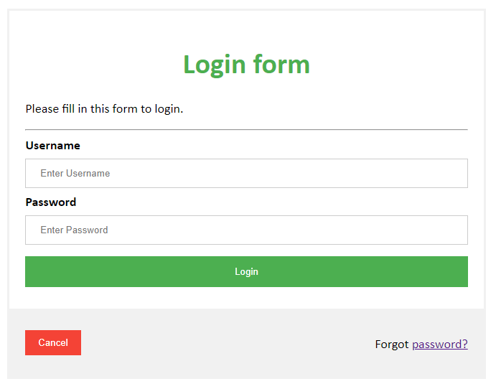

**Fig 5.7: Login Form**

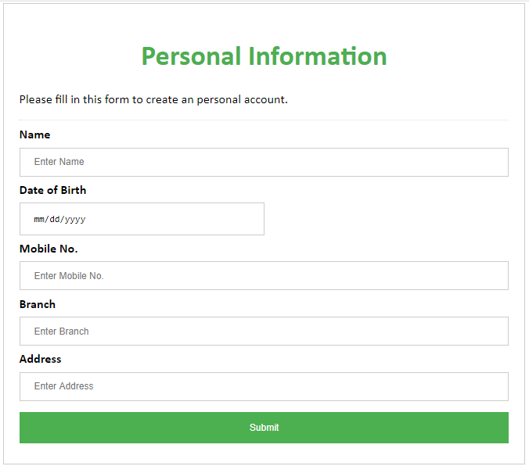

**Fig 5.8: Personal Details Form**

**Code snippets:**

**Code for fixed menu :**

<div class="menu">

<ul>

<li><a href="#feedback">Feedback</a></li>

<li><a href="#survey">Survey</a></li>

<li><a href="#mcq">MCQ</a></li>

<li><a href="#details">Personal Details</a></li>

<li><a href="#login_form">Login</a></li>

</ul>

</div>

**Code for login form:**

<form>

<div class="container">

<h1>Login form</h1>

<p>Please fill in this form to login.</p>

<hr>

<label for="uname"><b>Username</b></label>

<input type="text" placeholder="Enter Username" name="uname" required>

<label for="psw"><b>Password</b></label>

<input type="password" placeholder="Enter Password" name="psw" required>

<button type="submit">Login</button>

</div>

</div>

</form>

**Code for Details Form:**

<form style="border:1px solid #ccc">

<div class="container">

<h1>Personal Information</h1>

<p>Please fill in this form to create an personal account.</p>

<label for="email"><b>Name</b></label>

<input type="text" placeholder="Enter Name" required>

<label for="psw"><b>Date of Birth</b></label>

<br>

<input type="date" style="width: 50%">

<label for="psw-repeat"><b>Mobile No.</b></label>

<input type="text" placeholder="Enter Mobile No."required>

<label for="email"><b>Branch</b></label>

<input type="text" placeholder="Enter Branch"required>

<label for="psw"><b>Address</b></label>

<input type="text" placeholder="Enter Address" required>

<div class="clearfix">

<button type="submit" class="signupbtn">Submit</button>

</div>

</div></form>

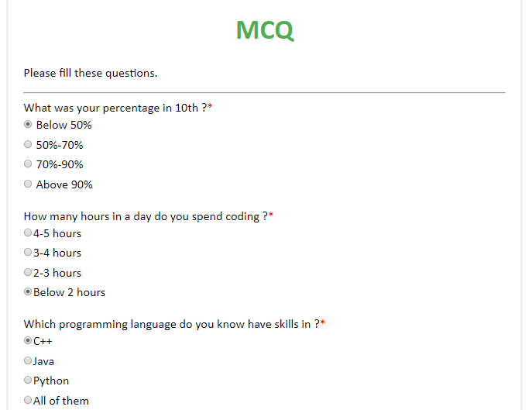

**Fig 5.7: MCQ Form**

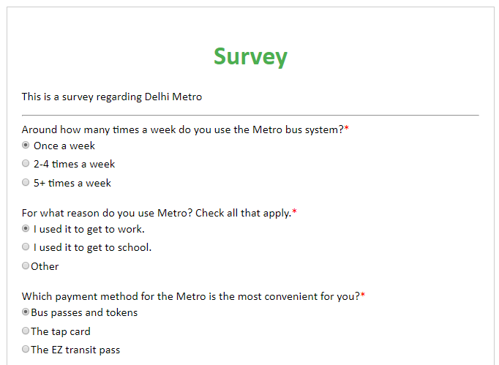

**Fig 5.8: Survey Form**

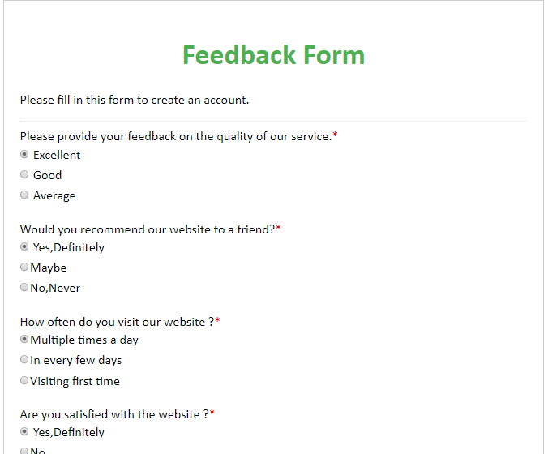

**Fig 5.8: Feedback Form**

**Code for MCQ form:**

<form>

<div class="container">

<h1>MCQ</h1>

<p>Please fill these questions.</p>

<hr>

<label>What was your percentage in 10th ?<span style="color:red">*</span></label>

<br>

<input type="radio" name="ser"checked> Below 50%<br>

<input type="radio" name="ser"> 50%-70%<br>

<input type="radio" name="ser"> 70%-90%<br>

<input type="radio" name="ser"> Above 90%

</form>

**Code for Survey form:**

<form style="border:1px solid #ccc">

<div class="container">

<h1>Survey</h1>

<p>This is a survey regarding Delhi Metro</p>

<hr>

<label>Around how many times a week do you use the Metro bus system?<span style="color:red">*</span></label>

<br>

<input type="radio" name="ser"checked> Once a week<br>

<input type="radio" name="ser"> 2-4 times a week<br>

<input type="radio" name="ser"> 5+ times a week

</form>

**Code for Feedback form:**

<form style="border:1px solid #ccc">

<div class="container">

<h1>Feedback Form</h1>

<p>Please fill in this form to create an account.</p>

<hr>

<label>Please provide your feedback on the quality of our service.<span style="color:red">*</span></label>

<br>

<input type="radio" name="ser"checked> Excellent<br>

<input type="radio" name="ser"> Good<br>

<input type="radio" name="ser"> Average

<textarea name="message" style="width:100%; height:100px">

</textarea>

<div class="clearfix">

<button type="submit" class="signupbtn">Submit</button></div>

</form>